Ideation Phase
Define the Problem Statements

Date | 14 FEB 2026
Team ID | LTVIP2026TMIDS65624
Project Name | prosperity prognosticator: machine learning for startup success
Maximum Marks | 2 Marks

Customer Problem Statement Template:
Create a problem statement to understand your customer's point of view. The Customer Problem Statement template helps you focus on what matters to create experiences people will love.
A well-articulated customer problem statement allows you and your team to find the ideal solution for the challenges your customers face. Throughout the process, you’ll also be able to empathize with your customers, which helps you better understand how they perceive your product or service.
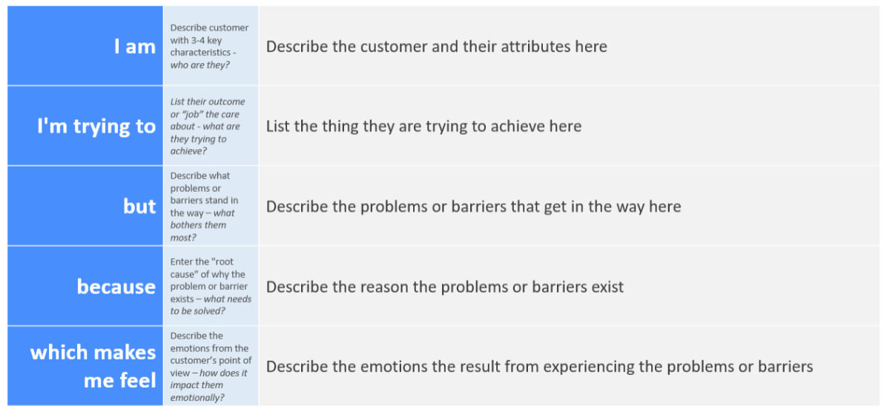
Reference: https://miro.com/templates/customer-problem-statement/
Example:
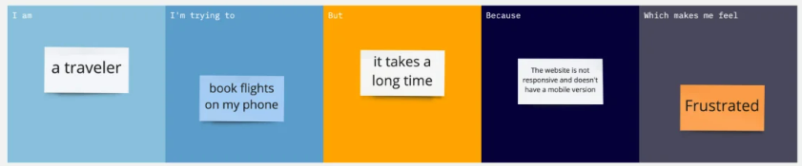
Problem Statement (PS) | I am (Customer) | I’m trying to | But | Because | Which makes me feel
PS-1 | I am pavan I want to start a startup company | For that I want check my success rate through a learning model | A proper learning application is not there | Lack of initiative in people to start a startup | I felt happy this will help for lot of people to built their empire.
PS-2 | I am kavya I wanted to start boutique business | For that I want a new learning model for testing my practices | Proper ml application is not there | Lack of knowledge | I felt very happy by knowing that this type of application will help lot for my kind of people.

